1) Create a union of two querries that shows the names,cities and ratings of all customers. Those with the rating of 200 or grater will also have the words “High Rating”, while the others will have the words “Low Rating”.

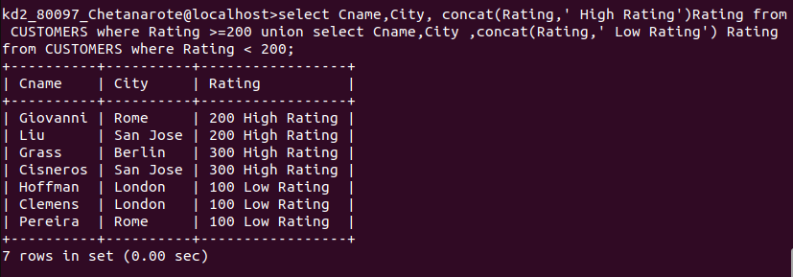

2) Write a command that produces name and the number of each salesperson and each customer with more than one current order. Put the results in alphabetical order.

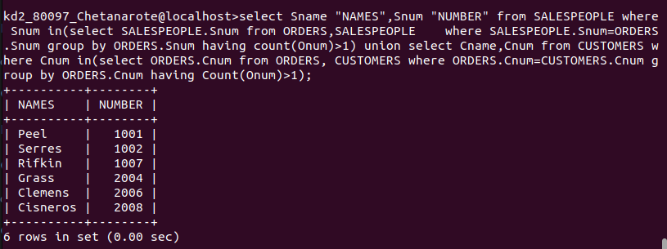

3) Form a union of three queries. Have the first select the snums of all salespeople in San Jose; the second , the sums of all customers in San Jose; and the third column of all orders on october 3. Retain duplicates between the last two queries bu t eliminate any reduncies between either of them and the first.

